Integers and Rationals Stem Lesson Ladder

PROGRESSION
Essential Foundational Knowledge (Roots) | - Whole numbers & the number line (points as numbers; 0, 1, unit segments).  - Fractions on the number line; unit fractions  - Properties: commutative/associative/distributive; additive inverse; multiplicative identity. (with fractions)  - Basic fraction algorithms (stated symbolically).
Leads to | - Irrational Numbers, Real Numbers  - Irrational numbers vs. rational numbers: placement of irrational numbers on a number line  - Algebraic manipulation with symbols (rational expressions; solving linear equations)
Big Ideas | Structure of the Number System  - Integers are numbers on the number line.  - Rational numbers are numbers on the number line.  - Properties of operations and of equality apply to all the numbers to the left of zero too
Other Information | Rational number — student-facing G6: A rational number is 0, a positive fraction, or the opposite of a positive fraction.  Rational number — underlying definition [student facing g7]: A rational number is any number that can be written as $\frac{m}{n}$, where $m$and $n$are integers and $n≠0$. (will need to upgrade definition for division/decimal stuff)

Concept/Skill: Plot rational numbers on a number line and name opposites of rational numbers.

Goal | - Understand numbers could be on either side of 0.  - Understand the definition of integers as whole numbers and opposites of whole numbers on the number line.  - Understand all whole numbers are integers but not all integers are whole numbers.  - Understand the definition of rational numbers as fractions and their opposites.  - Understand the absolute value of a rational number is its distance from 0.
Student-Facing Example | 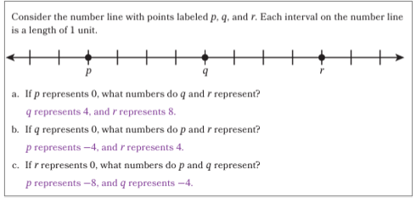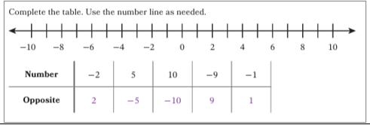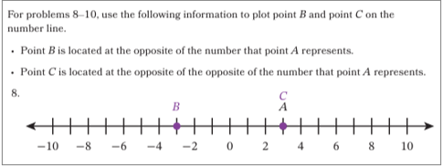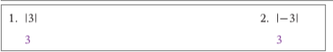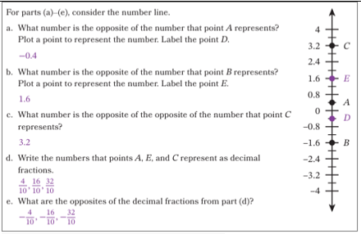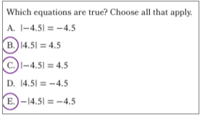
Knowledge Graph Node | Name the opposite of a rational number. | Plot integers on a number line. | Plot rational numbers on a number line. | Classify numbers as whole numbers, integers, fractions, and rational numbers and describe the relationships between these sets of numbers. | Find the absolute value of a rational number. | Plot rational numbers and their absolute values on a number line.
Terminology | - Opposite of a number: For a given number, the opposite of the number is the point on the number line that is the same distance from 0, but on the other side of 0.  - Integer: An integer is a whole number or the opposite of a whole number.  - Rational Number: A rational number is a fraction or the opposite of a fraction [note: this definition is fine for G6 when we’re just getting started. In g7 when we have to upgrade. At the start of Grade 6, we can treat rational numbers as fractions and their opposites on the number line. By the decimal-expansion and division work, students need the stronger quotient-of-integers meaning.] |  |  |  | - Absolute value: The absolute value of a number is its distance from 0 on the number line. | - Absolute value: The absolute value of a number is its distance from 0 on the number line.
Mathematical Models | - Horizontal and vertical number lines | - Horizontal and vertical number lines | - Horizontal and vertical number lines |  | - Horizontal and vertical number lines | - Horizontal and vertical number lines
Strategies
Specifications | Use the number line to define opposite numbers (develops understanding that numbers can be located to the left of 0 on the number line).  Identify 0 as the opposite of 0.  Define integers as the set of all whole numbers and their opposites.  Define rational numbers as the set of all fractions and their opposites.  Identify positive integers as opposites of negative integers. [nope. Not until we know what “negative” means. -danielle]  Identify the opposite of the opposite of an rational number as the rational number, e.g., -(-p)=p  [hey guys. Kids don’t know what “negative” is yet. All they have at this point is “opposite”. If you need the descriptor “negative”, make explicit to kids what you mean by that word.-danielle] |  | Include some integers to reinforce the idea that integers are rational numbers. |  | Understand the absolute value of a positive rational number is the number.  Understand the absolute value of a negative rational number is the opposite of the number.  Identify 0 as the absolute value of 0.  [hey guys. Kids don’t know what “negative” is yet. All they have at this point is “opposite”. -danielle] | Talk about distance and direction, but do not use the term “vector” until later (see Add Rational Numbers concept/skill).
Leaves to Include
Considerations | Use positive integers, negative integers, 0 to describe quantities (e.g. temperature).  Can use positive rational numbers, negative rational numbers, 0 to describe quantities (e.g. money). | [the “opposite” definition is fine for G6 when we’re just getting started. In g7 when we have to upgrade. At the start of Grade 6, we can treat rational numbers as fractions and their opposites on the number line. By the decimal-expansion and division work, students need the stronger quotient-of-integers meaning.] |  | Make sure to include and emphasize in instruction that all whole numbers are integers (but not all integers are whole numbers!) Ask… is 5 a…. whole number? Integer? Fraction? Rational number? And then do -5. Etc.  always, sometimes, never maybe good here. Ex: Integers are Whole numbers (sometimes- give examples of integers that are whole numbers and examples of integers that are not)  Consider upgrading definition of rational here. If not, must be done by G7. | You absolutely (pun intended) have to have “absolute value” in place in order to find the “opposite” of a number. Absolute value is distance from 0 and “opposite number” is a number the same distance from zero on the other side of 0.
Required Skills/Cases | - Identify opposites of whole numbers  - Identify opposites of negative integers  - Identify opposites of rational numbers  - Identify opposite of 0.  - Identify opposites of opposites of rational numbers | - . |  | -Given a number, classify.  - Given a type of number, name examples.  - Explain why all whole numbers are integers, and give examples of integers that are not whole numbers  -Explain why all integers are rational numbers, and give examples of rational numbers that are not integers | - Find absolute value of positive number  - Find absolute value of 0  - Find absolute value of negative number  - Find the opposite of the absolute value of a number  Examples: -|2|, -|-2|
Misconceptions | Some students may conflate “opposite” and “negative”. |  |  | Whole numbers aren’t integers. Integers, written as a/b aren’t integers
Existing Product Reference, if any | EM2 Grade 6 M3 Lesson 1 Launch and Learn 1,2 (focus on opposites)  EM2 Grade 6 M3 Lesson 2  EM2 Grade 6 M3 Lesson 3 | EM2 Grade 6 Module 3 Lessons 1, 2 | EM2 Grade 6 M3 Lesson 3 |  | EM2 Grade 6 Module 3, Grade 6 Module 3 Lesson 7 Learn 1 | EM2 Grade 6 Module 3, Grade 6 Module 3 Lesson 7 Learn 1
Grade (or Leaf) | 6 | 6 | 6 |  | 6 | 6
Notes related to Standards, Grade, or Leaf | 6.NS.C.5, 6.NS.C.6.a, 6.NS.C.6.c  FL.6.NSO.1.1, FL.6NSO.1.2  TX.6.2C  NE.6.N.1.e | 6.NS.C.6.c  TX.6.2C | 6.NS.C.6.c  TX.6.2C | 6.NS.C.6 | 6.NS.C.7.c  FL.6.NSO.1.3  NE.6.N.1.e  ND.7.NO.NS.1  OK.7.N.1.3 | 6.NS.C.7.c  NE.6.N.1.e  ND.7.NO.NS.1  OK.7.N.1.3
Notes for Intervention, Extension, or Optional Activities
Additional Notes | Vertical number lines and linking positive numbers to ‘above 0’ and negative numbers to ‘below 0’ could be an easier entry point than starting with horizontal number lines.  Identify opposites of quantities in real-world contexts, e.g., 4 degrees above/below freezing (in degrees Celsius). Identify opposites of quantities in real-world contexts, e.g., earning a wage of $14.75 per hour; owing $11.95.  Understand that all whole numbers are integers, not all integers are whole numbers  Understand all integers are rational numbers but not all rational numbers are integers: integers identified as $\frac{n}{1}$.  1 day total for integers and rational numbers | 1 day | 1 day |  | 1 day total for finding and plotting | 1 day

Concept/Skill: Compare and order rational numbers.

Goal | - Extend concept of order among numbers from fractions to all rational numbers: for any numbers x and y on the number line, x<y means that x is to the left of y, or y>x.
Student-Facing Example | 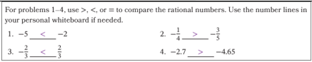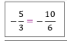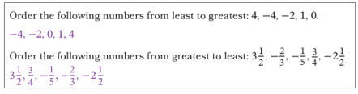
Knowledge Graph Nodes | Compare and order integers. | Compare and order rational numbers. | Show that between any 2 rational numbers is another rational number. | Compare absolute values of rational Numbers.
Terminology | Recall definitions of <, >, = (oh look, coherence)  This is probably a good spot to define negative. Let the “opposite” idea breathe a little before we give a name to the left hand side of the number line | Recall definitions of <, >, = (oh look, coherence)
Mathematical Models | Horizontal and vertical number lines | Horizontal and vertical number lines |  | Horizontal and vertical number lines  Vectors
Strategies | Use positions on the number line. | Use positions on the number line and common denominators. |  | Compare lengths of vectors
Specifications |  | Limit to simpler cases if comparing decimals and fractions, e.g., where students can use benchmarks or compare based on signs of the numbers, e.g., -0.25 < 1/5
Leaves to Include
Considerations |  | - Compare quantities in applications.  - Need to recall definitions of less than, greater than, equal to as left/right/same location on number line.
Required Skills/Cases | - Compare two integers, one positive, one negative  - Compare two negative integers  - Order a list of integers from least to greatest or vice versa | - Compare two rational numbers, one positive, one negative  - Compare two rational numbers that are both negative  - Don’t forget about zero, and  - comparing two positives is ok in a problem set, or as part of a problem, but shouldn’t count as completing the node  - Order a list of rational numbers from least to greatest or vice versa  Number types  - Compare two fractions with common denominators  - Compare two fractions with unlike denominators  - Compare rational numbers represented as decimals  - Compare rational numbers represented in different forms, e.g., fraction and decimal where conversion is “easy”, e.g., -1/4<-0.2  - Include rational numbers whose absolute values are greater than 1 (see student-facing example)  - Include rational numbers written as mixed numbers.  - Include examples where rational numbers are equal. |  | Compare absolute values of integers  Compare absolute values of rational numbers represented as fractions  Recognize that comparing absolute value is the same as comparing rational numbers when both numbers are positive, e.g., ¾ > ½ and |3/4| > |1/2|  Recognize that comparing absolute value is the opposite of comparing rational numbers when both numbers are negative, e.g., -3<-2 but |-3|>|-2|
Misconceptions | Comparing by magnitude (e.g., -2 < -5) | Comparing by magnitude (e.g., -2 ¼ > -3/4)
Existing Product Reference, if any | EM2 Grade 6 Module 3 Lesson 5 Learn segments  EM2 Grade 6 Module 3 Lesson 6 Learns 1 and 3 | EM2 Grade 6 Module 3 Lesson 5 Learn segments  EM2 Grade 6 Module 3 Lesson 6 Learns 1 and 3 |  | EM2 Grade 6 Module 3 Lesson 8 Learn 1
Grade (or Leaf) | 6 | 6 | Leaf | Leaf
Notes related to Standards, Grade, or Leaf | 6.NS.C.7.a, 6.NS.C.7.b  OK.6.N.1.2 (comparing positive rational numbers or integers) | 6.NS.C.7.a, 6.NS.C.7.b  OK.6.N.1.2, SC.6.NR.2.1, SC.6.NR.2.2- limited to comparing positive rational numbers with restrictions on permissible denominators. | AZ. AZ.8.NS.A.3- only part of the standard (also includes understanding that there is an irrational number between any two rational numbers) | 6.NS.C.7.d, FL.6.NSO.1.4, NE.6.N.1.e, OK.7.N.1.1
Notes for Intervention, Extension, or Optional Activities
Additional Notes | 1 day (could address both integers and rational numbers in one day)* | Fluency: Use inequalities to compare positive rational numbers.  1 day*

Concept/Skill: Convert between fractions and decimals.

Goal | - Understand fractions with a denominator of the form $2^{a}5^{b}$(in lowest terms) is a terminating decimal; otherwise a repeating decimal.
Student-Facing Example | 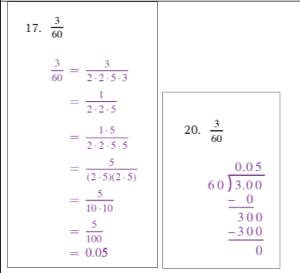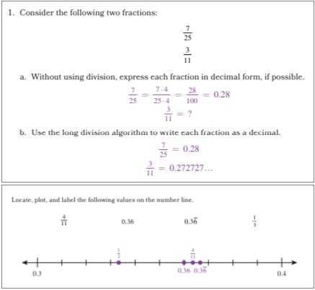
Knowledge Graph Nodes | Determine whether a rational number has a terminating or repeating decimal expansion by analyzing the denominator. | Write fractions as decimals. | Write decimals as fractions.
Terminology | [the “opposite” definition is fine for G6 when we’re just getting started. In g7 when we have to upgrade. At the start of Grade 6, we can treat rational numbers as fractions and their opposites on the number line. By the decimal-expansion and division work, students need the stronger quotient-of-integers meaning.] | [the “opposite” definition is fine for G6 when we’re just getting started. In g7 when we have to upgrade. At the start of Grade 6, we can treat rational numbers as fractions and their opposites on the number line. By the decimal-expansion and division work, students need the stronger quotient-of-integers meaning.] | [the “opposite” definition is fine for G6 when we’re just getting started. In g7 when we have to upgrade. At the start of Grade 6, we can treat rational numbers as fractions and their opposites on the number line. By the decimal-expansion and division work, students need the stronger quotient-of-integers meaning.]
Mathematical Models
Strategies | Prime factorization | - Prime factorization  Long division | Solving an equation
Specifications
Leaves to Include
Considerations | Students should be able to explain why denominators with only factors 2 and/or 5 terminate.  Use equivalent fraction reasoning.  Strong understanding of rational number, terminating is needed.  Connection to percents.  Writing decimal fractions as fractions will be review. Use it as a bridge to making sense of why the prime factorization of a denominator can be used to determine whether a decimal expansion is terminating or repeating. | Use bar notation for repeating decimals.  Technology? | Definition of rational number needs to be well understood.  Terminating decimals- students use powers of 10 as denominator.  Repeating decimal conversion is an application of solving linear equations.
Required Skills/Cases | Explain why fractions with denominators that are powers of 10 have a terminating decimal expansion.  Write fractions with denominators that are powers of 10 as a terminating decimal.  Explain why fractions with denominators with only factors 2 and/or 5 terminate.  Explain why fractions with denominators with factors other than 2 or 5 repeat.  Write fractions with only 2 or 5 in denominator as terminating decimal. | Convert fractions with denominators that are factors of 2 and 5 to terminating decimals  Convert fractions to repeating decimals  Convert both positive and negative fractions to decimals  Include examples where the magnitude of a fraction is greater than 1. | Convert terminating decimals to fractions.  Use an algebraic method to convert repeating decimals to fractions.
Misconceptions
Existing Product Reference, if any | Grade 7 Module 2 Lesson 19 | Grade 7 Module 2 Lesson 19 Learns 2 and 3  Grade 7 Module 2 Lesson 20 Learns 2-4 | G8M4L5 and L6
Grade (or Leaf) | 7 | 7 | 7/8
Notes related to Standards, Grade, or Leaf | 7.NS.A.2.d  FL.6.NSO.3.5  KY.6.NS.2.a  SC.8.NR.1.1  KY.6.NS.2.b | 7.NS.A.2.d  FL.6.NSO.3.5  KY.6.NS.2.a  SC.8.NR.1.1  KY.6.NS.2.b  NOTE: Some of these standards cover percentages and only positive numbers
Notes for Intervention, Extension, or Optional Activities | Prime factorization | Use long-division remainders to motivate why rational numbers yield repeating/terminating decimals (optional extension). | Proof of algebraic method for converting from repeating decimals to fractions.
Additional Notes | 1 instructional day | 2 instructional days  Day 1- (convert fractions to terminating decimals) [this will be review from g5)  Day 2- convert fractions to repeating decimals | 2 instructional days  1 day for converting terminating decimals to fractions  1 day for converting repeating decimals to fractions

Concept/Skill: Add rational numbers.

Goal | - Understand vector equality and vector addition on a number line.  - Understand proof: Addition of vectors is commutative/ associative.  - Understand $x+y$ is the endpoint of the vector sum $\vec{x}+\vec{y}$.  - Understand theorems: (for s and t positive)  $s+t=s+t$ (important because shows that using the vectors to add works the same as the concatenation of line segments we know and love – we won’t get anything weird)  $(-s)+(-t) = -(s+t)$ (important because shows adding two negative numbers always gives negative number)  $s+\left(-t\right)=-t+s=\left\{\begin{aligned}\left(s-t\right) \text{if} s≥t \\ -\left(t-s\right) \text{if} s<t\end{aligned}\right.$ (important because shows commutativity, adding a negative is the same as subtracting a positive, and tools for mental math with negatives, and who knows what sign we’re going to get!  - Understand proof: addition of rational numbers is commutative/associative.  - Understand additive inverses, additive identity.  - Understand proof that for integers $k,l,m,n$ with $l,n≠0$: $\frac{k}{l}+\frac{m}{n}=\frac{kn+ml}{ln}$.  - Fluently add rational numbers. Fluently compute with symbols/equations (see student facing sample).
Student-Facing Example | 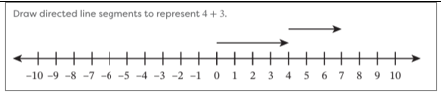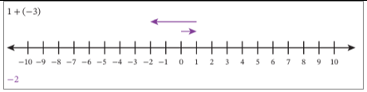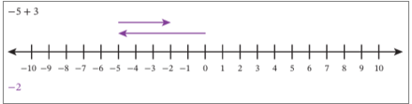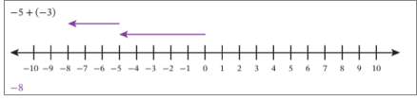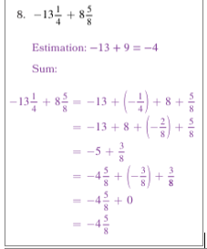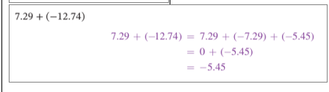
Knowledge graph nodes | Add vectors. | Explain patterns in the addition of rational numbers. | Add integers. | Add rational numbers.
Terminology | - Vector: A vector is a line segment with both length and direction.  - Define vector addition |  | Define integer addition in terms of vectors  Additive inverse: The additive inverse of a number n, is the number k such that n+k=k+n=0 | Define rational addition in terms of vectors
Mathematical Models | Horizontal and vertical number lines | Number lines, vectors | Horizontal and vertical number lines | Horizontal and vertical number lines
Strategies |  | Informal “proofs” of the properties of addition, extended to all rational numbers | Use vector addition. | - Use vector addition first.  - Use decomposition (extends a strategy students have for positive number addition).  Use additive inverses, decomposition. Extend any strategies that kids already have for positive number addition.
Specifications | Relate vector addition to representing sums of positive numbers with concatenating line segments.  Show a proof that that vector addition is commutative and associative.  Convention that second endpoint is drawn above the first one (when they have opposite signs). |  | Apply commutative and associative properties of addition
Leaves to Include
Considerations | Light touch with “vectors” here. The idea is to connect it to how they’ve been adding positive numbers on the number line since G3. | Can do a bunch of specific examples (like in em2), then the proof of the general case. Do not assume general case follows from looking at a couple examples (like in em2) -danielle  Show that in general for s and t positive:  $s+t=s+t$. In words: show that vector addition for positive rational numbers works exactly how we expect. (important because shows that using the vectors to add works the same as the concatenation of line segments we know and love – we won’t get anything weird)  $(-s)+(-t) = -(s+t)$. In words: show that the sum of two negative rational numbers is a negative number that’s the sum of the corresponding positive numbers. (wording needs massaging. Do not print -danielle)  (important because shows adding two negative numbers always gives a negative number that’s the sum of the corresponding positive numbers)  $s+\left(-t\right)=-t+s=\left\{\begin{aligned}\left(s-t\right) \text{if} s≥t \\ -\left(t-s\right) \text{if} s<t\end{aligned}\right.$  in words: the sign of the sum of a negative rational number and a positive rational number is determined by the relative absolute values of the addend in a particular way  (important because shows commutativity, adding a negative is the same as subtracting a positive, and tools for mental math with negatives, and who knows what sign we’re going to get!  - Understand proof: addition of rational numbers is commutative/associative.  - Understand additive inverses, additive identity.  - Understand proof that for integers $k,l,m,n$ with $l,n≠0$: $\frac{k}{l}+\frac{m}{n}=\frac{kn+ml}{ln}$. | - Teach integer addition before addition of rational numbers.  - Include word problems.  - Understand $x+y$ is the endpoint of the vector sum $\vec{x}+\vec{y}$. | - Teach integer addition before addition of rational numbers.  - For rational numbers, can find estimate first.  - Apply and name properties.  Avoid LCD as standard operating procedure.  - Understand $x+y$ is the endpoint of the vector sum $\vec{x}+\vec{y}$.
Required Skills/Cases | Addition of two positive numbers  Addition of three positive numbers  Addition of a positive number and a negative number  Addition of two negative numbers | - Describe patterns in actual number examples that correspond to the general cases below  Create conjectures after repeated examples.  - for s and t positive  - $s+t=s+t$  - $(-s)+(-t) = -(s+t)$  - $s+\left(-t\right)=-t+s=\left\{\begin{aligned}\left(s-t\right) \text{if} s≥t \\ -\left(t-s\right) \text{if} s<t\end{aligned}\right.$  - addition of rational numbers is commutative/associative.  - additive inverses, additive identity.  - for integers $k,l,m,n$ with $l,n≠0$: $\frac{k}{l}+\frac{m}{n}=\frac{kn+ml}{ln}$. | First addend positive, second negative (positive sum)  First addend positive, second negative (negative sum)  Opposites (additive inverse)  First addend negative, second positive (positive sum)  First addend negative, second positive (negative sum)  Two negative addends  More than two addends | - Two addends with same sign, opposite signs, positive sum, negative sum (see cases for adding integers)  - More than two addends
Misconceptions | Longer vector means greater number |  |  | Errors in decomposing negative rational numbers, e.g., -3.5 = -3 + 0.5
Existing Product Reference, if any | EM2 Grade 7 Module 2 Lesson 2 (positive addends only) |  | EM2 Grade 7 Module 2 Lesson 2 | EM2 Grade 7 Module 2 Lessons 5, 6
Grade (or Leaf) | 7 | 7 | 7 | 7
Notes related to Standards, Grade, or Leaf | 7.NS.A.A.1.b  MS.6.NS.9b  NC.6.NS.9  (note- these standards do not explicitly reference vectors) | 7.NS.A.1 | 7.NS.A.1.a  7.NS.A.1.b  7.NS.A.1.d  MS.6.NS.9d  OK.6.N.2.3  SC.6.PAFR.3.3  SC.6.PAFR.3.5  VA.6.CE.2.b  NC.6.NS.9  Procedural fluency with integer addition:  FL.6.NSO.4.1  TX.6.3.D  Estimate sums of integers to assess reasonableness of results: OK.6.N.2.1 | 7.NS.A.1.b, 7.NS.A.1.d  ND.8.NO.O.2  Focus on procedural fluency:  FL.7.NSO.2.2  TX.7.3A
Notes for Intervention, Extension, or Optional Activities | Intervention lesson or lesson 0, we need to tie this back to whole number addition and subtraction by using the number line. Even if we show ‘hops’ and those ‘hops’ are related to the vectors. (EK)
Additional Notes | Reinforce that longer vector means greater magnitude and direction indicates whether addend is positive or negative.  1 day |  | Understand the additive inverse.  Understand that adding integers is associative.  Address Commutative property of addition so students can leverage mental math and reason about the signs of sums  Use Distributive property to show –s + -t = -(s+t)  2 days:  Day 1: Add by using vectors  Day 2: Use properties and mental math to add integers | Understand proof that for integers $k,l,m,n$ with $l,n≠0$: $\frac{k}{l}+\frac{m}{n}=\frac{kn+ml}{ln}$.  Understand that addition of rational numbers is associative.  2 days:  Day 1: Add rational numbers by using vectors; Use additive inverses to add rational numbers.  Day 2: Use decomposition to add rational numbers.

Concept/Skill: Subtract rational numbers.

Goal | - Extend definition of subtraction (missing addend) to integers, then to rational numbers.  - Understand theorems:  $$s+t=s+t$$  $-s-t = -(s+t)$  $s-t=-t+s=\left\{\begin{aligned}\left(s-t\right) \text{if} s≥t \\ -\left(t-s\right) \text{if} s<t\end{aligned}\right.$  - Extend definition of subtraction (missing addend) to rational numbers.  - Understand proof that for integers $k,l,m,n$ with $l,n≠0$:  $\frac{k}{l}-\frac{m}{n}=\frac{kn-ml}{ln}$.  - Fluently subtract rational numbers. Fluently compute with symbols.
Student-Facing Example | 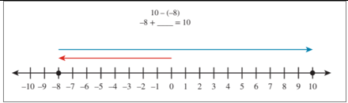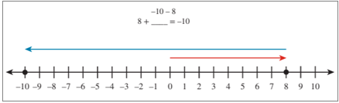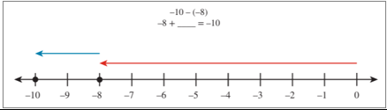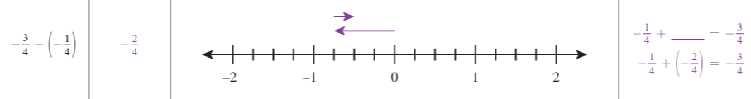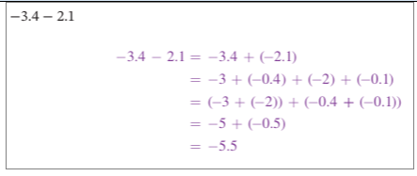
Knowledge graph nodes | Write subtraction expressions as unknown addend equations. | Explain patterns in the subtraction of rational numbers. | Subtract integers. | Subtract rational numbers.
Terminology | - Extend definition of subtraction (missing addend) to integers, then to rational numbers.
Mathematical Models | Horizontal and vertical number lines | Informal “proofs” of the properties of subtraction, extended to all rational numbers | Horizontal and vertical number lines | Horizontal and vertical number lines
Strategies | - Use unknown addend equation and vector addition.  - Establish:  $$x-y=x+(-y)$$ | Unknown addend equations and vector addition. | - Use unknown addend equation and vector addition. | - Use unknown addend equation and vector addition first.
Specifications |  |  | Estimate differences before subtracting to determine reasonableness of solutions. | Estimate differences before subtracting to determine reasonableness of solutions.
Leaves to Include |  |  |  | Include problems that require subtraction of rational numbers written in different representations (e.g., fraction, decimal).
Considerations | Once we know how to add rational numbers, we can turn ALL subtraction problems into addition problems that we do know how to do. | - Definition of subtraction as unknown addend is crucial. | - Teach subtraction of integers before subtraction of rational numbers.  Include word problems. | - Find estimate first.  - Apply and name properties; avoid LCD as the “right way” to do the problem.  Include word problems.
Required Skills/Cases | - Positive minus positive (positive, negative difference)  - Positive minus negative  - Negative minus positive  - Negative minus negative (positive, negative differences) | Can do a bunch of specific examples (like in em2), then the proof of the general case. Do not assume general case follows from looking at a couple examples (like in em2) -danielle  Create conjectures after repeated examples.  Show:  - $-s-t = -(s+t)$  - $s-t=-t+s=\left\{\begin{aligned}\left(s-t\right) \text{if} s≥t \\ -\left(t-s\right) \text{if} s<t\end{aligned}\right.$  -for integers $k,l,m,n$ with $l,n≠0$:  $\frac{k}{l}-\frac{m}{n}=\frac{kn-ml}{ln}$.  - Show that every subtraction expression can be written as an equivalent addition expression | - Positive minus positive (positive, negative difference)  - Negative minus positive  - Positive minus negative  - Negative minus negative (positive, negative differences)  - Evaluating expressions with addition and subtraction of more than 2 integers  Example: 4 – 5 – 2  Example: -4 + (-5) – 2  Example: -4 –(5+2) | - Positive minus positive (positive, negative difference)  - Negative minus positive  - Positive minus negative  Negative minus negative (positive, negative differences)  Evaluate expressions with addition and subtraction of more than 2 rational numbers  Example: 2/5 – 1/3 – 4/5  Example: -2 ½ + $1\frac{1}{3}$ – 3.2
Misconceptions
Existing Product Reference, if any | Grade 7 Module 2 Lesson 7 Learns |  | Grade 7 Module 2 Lesson 8 Learns 2 and 3, Lesson 9 | Grade 7 Module 2 Lesson 10 Learn 3 , Lesson 11
Grade (or Leaf) | 6/7? | 7 | 6/7? | 7
Notes related to Standards, Grade, or Leaf | 7.NS.A.1.c  7.NS.A.1.d  VA.6.CE.2.b  SC.6.PAFR.3.5  OK.6.N.2.3  NC.6.NS.9  MS.6.NS.9d  MS.6.NS.9c  Use models to represent integer subtraction: OK.6.N.2.2  VA.6.CE.2.a | 7.NS.A.1 | 7.NS.A.1.c  7.NS.A.1.d  VA.6.CE.2.b  SC.6.PAFR.3.5  OK.6.N.2.3  NC.6.NS.9  MS.6.NS.9d  MS.6.NS.9c  Focus on procedural fluency with subtracting integers: FL.6.NSO.4.1  TX.6.3D  Focus on estimating differences to determine whether solutions are reasonable: OK.6.N.2.1 | 7.NS.A.1.c, 7.NS.A.1.d  ND.8.NO.O.2  Focus on procedural fluency:  FL.7.NSO.2.2  TX.7.3A
Notes for Intervention, Extension, or Optional Activities
Additional Notes | 1 day |  | 2 days- 1 day for representing on number lines and rewriting subtraction expressions as addition expressions; 1 day for evaluating differences by rewriting as sums. | 2 days  Second day include word problems

Concept/Skill: Multiply rational numbers.

Goal | - Understand theorem and proof for rational number $s$:  $$\left(-1\right)\left(s\right)=-s$$  We know $s+\left(-s\right)=0$.  $s+\left(-1\right)\left(s\right)=s\left(1+\left(-1\right)\right)$ $=s\left(0\right)$ $=0$  Since $s+\left(-s\right)=0$ and  $s+\left(-1\right)\left(s\right)=0$,  $\left(-1\right)\left(s\right)=-s$.  - Understand theorem and proof for rational numbers $s,t$:  $$\left(-s\right)t=-\left(st\right)$$  $$s\left(-t\right)=-\left(st\right)$$  - Understand theorem and proof: $\left(-1\right)\left(-1\right)=1$  We know $-1+1=0.$  Let $x=(-1)(-1)$.  $-1+x=-1+(-1)(-1)$ $=-1\left(1+\left(-1\right)\right)$ $=-1(0)$ $=0$  Since $-1+1=0$ and $-1+x=0$, $x=1$. Therefore $\left(-1\right)\left(-1\right)=1$.  - Understand theorem and proof for rational numbers $s,t$:  $(-s)(-t)=st$  - Fluently multiply rational numbers. Fluently compute with symbols.
Student-Facing Example | 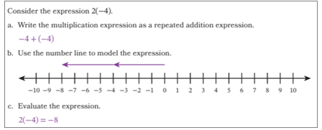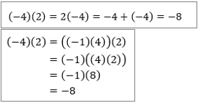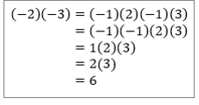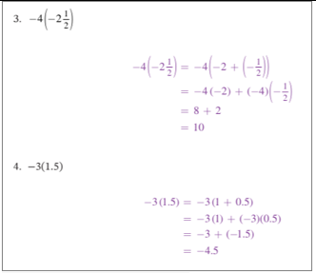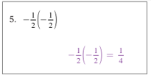
Rough lesson objectives | Explain patterns in the multiplication of rational numbers. | Multiply integers. | Multiply rational numbers.
Terminology | Extend definition of fraction multiplication to rational numbers
Mathematical Models | Informal “proofs” of the properties of multiplication, extended to all rational numbers | Number line
Strategies | Repeated addition initially. Then commutative property.  Justify sign “rules” using distributive, associative, commutative  Extend rules for whole numbers and fractions to integers and rational numbers | - Use repeated addition and commutative property.  - Insist that distribution, associativity, commutativity hold.  - Justify sign rules by using distributive, associative, commutative properties. | - Insist that distribution, associativity, commutativity hold, and that we don’t break fraction*fraction, multiplicative identity.  Justify sign rules for integers and rational numbers by using distributive, associative, commutative properties.
Specifications
Leaves to Include
Considerations | We already know how to multiply the positive rationals. And we want assoc/comm/distrib for multiplication to continue to be true for negative rationals. Then the theorems below just… fall out  - Understand theorem and proof for rational number $s$:  $$\left(-1\right)\left(s\right)=-s$$  We know $s+\left(-s\right)=0$.  $s+\left(-1\right)\left(s\right)=s\left(1+\left(-1\right)\right)$ $=s\left(0\right)$ $=0$  Since $s+\left(-s\right)=0$ and  $s+\left(-1\right)\left(s\right)=0$,  $\left(-1\right)\left(s\right)=-s$.  - Understand theorem and proof for rational numbers $s,t$:  $$\left(-s\right)t=-\left(st\right)$$  $$s\left(-t\right)=-\left(st\right)$$  - Understand theorem and proof: $\left(-1\right)\left(-1\right)=1$  We know $-1+1=0.$  Let $x=(-1)(-1)$.  $-1+x=-1+(-1)(-1)$ $=-1\left(1+\left(-1\right)\right)$ $=-1(0)$ $=0$  Since $-1+1=0$ and $-1+x=0$, $x=1$. Therefore $\left(-1\right)\left(-1\right)=1$.  - Understand theorem and proof for rational numbers $s,t$:  $(-s)(-t)=st$ | Word problems | Word problems & estimates
Required Skills/Cases | - Show for rational number $s$:  $$\left(-1\right)\left(s\right)=-s$$  - Show for rational numbers $s,t$:  $$\left(-s\right)t=-\left(st\right)$$  $$s\left(-t\right)=-\left(st\right)$$  - Show: $\left(-1\right)\left(-1\right)=1$  - Show for rational numbers $s,t$:  $(-s)(-t)=st$ | First factor positive, second factor negative  First factor negative, second factor positive  Two negative factors | Product of positive rational number and negative rational number  Product of two negative rational numbers  More than 2 factors: even number of negative rational number factors  More than 2 factors: odd number of rational number factors
Misconceptions
Existing Product Reference, if any |  | Grade 7 Module 2 lesson 13 Learn 1 | Grade 7 Module 2 Lesson 15 Learns 3 and 4
Grade (or Leaf) |  | 6/7? | 7
Notes related to Standards, Grade, or Leaf |  | 7.NS.A.2  7.NS.A.2.a  7.NS.A.2.c  SC.6.PAFR.3.5  VA.6.CE.2.b  Focus on models: VA.6.CE.2.a  Procedural fluency with multiplying integers: FL.6.NSO.4.2  TX.6.3D | 7.NS.A.2  7.NS.A.2.a  7.NS.A.2.c  ND.8.NO.O.2  Procedural fluency: FL.7.NSO.2.2  TX.6.3E  TX.7.3A
Notes for Intervention, Extension, or Optional Activities |  |  | Preview multiplication by negative reverses the inequality. Use vectors on number line – revisit in “solving inequalities”
Additional Notes |  | 2 days (one positive, one negative factor; two negative factors) | 2 days (one day for more than two factors and word problems)

Concept/Skill: Divide rational numbers.

Goal | - Understand existence and uniqueness of “missing factor” in integer multiplication.  - Understand and prove zero product property.  - Understand for whole numbers $p$ and $q$:  $\frac{-p}{q}=\frac{p}{-q}=-\frac{p}{q}$  $\frac{-p}{-q}=\frac{p}{q}$  - For $p$, $q$ rational numbers, define division of $p$ by $q$ ($q≠0$) as the unique $x$ with $qx=p$; (existence and uniqueness here, light touch)  - Understand existence and uniqueness of multiplicative inverses in rational numbers  - Understand multiplicative inverses and negative rational numbers.  - Note: emphasize nonzero requirement for divisors.  - Rational over a rational – (ie, complex fractions, but now with negative signs)  Fluently divide rational numbers.
Student-Facing Example | 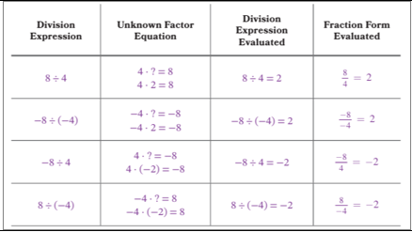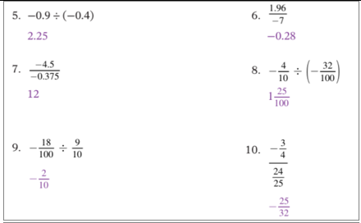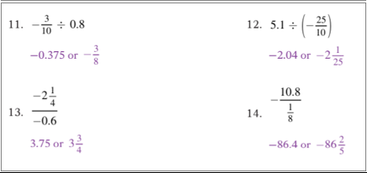
Rough lesson objectives | Write division expressions as unknown factor multiplication equations. | Explain patterns in the division of integers and rational numbers. | Find quotients of integers. | Find quotients of rational numbers.
Terminology | - Extend definition of division (missing factor) to integers, then to rational numbers. | - Extend division to rational numbers:  For $p$, $q$ rational numbers, define division of $p$ by $q$ ($q≠0$) as the unique $x$ with $qx=p$; (existence and uniqueness here, light touch)  - Multiplicative inverses
Mathematical Models
Strategies | - Use unknown factor equation | - Informal “proof”  - Use unknown factor equation and relationship between multiplication and division.  Show every division expression can be written as an equivalent multiplication expression | - Use unknown factor equation.  Justify steps by named properties. | Multiply by the reciprocal.
Specifications
Leaves to Include
Considerations | Once we know how to multiply rational numbers, we can turn ALL division problems into multiplication problems that we do know how to do.  Connect to how we use addition to figure out subtraction problems | - Understand and prove zero product property.  - Understand for whole numbers $p$ and $q$:  $\frac{-p}{q}=\frac{p}{-q}=-\frac{p}{q}$  $\frac{-p}{-q}=\frac{p}{q}$  - For $p$, $q$ rational numbers, define division of $p$ by $q$ ($q≠0$) as the unique $x$ with $qx=p$; (existence and uniqueness here, light touch)  - Understand existence and uniqueness of multiplicative inverses in rational numbers  - Understand multiplicative inverses and negative rational numbers.  - Note: emphasize nonzero requirement for divisors. | Word problems and estimates
Required Skills/Cases | - Positive divided by positive (positive, negative difference)  - Positive divided by negative  - Negative divided by positive  - Negative divided by negative (positive, negative differences) | - Show zero product property  - Show for whole numbers p and q, q not 0  $\frac{-p}{q}=\frac{p}{-q}=-\frac{p}{q}$  $\frac{-p}{-q}=\frac{p}{q}$
Misconceptions
Existing Product Reference, if any |  | Grade 7 Module 2 Lesson 13 Learn 2 | Grade 7 Module 2 Lesson 18 Learns 1, 3  EM2 Grade 7 Module 2 Lesson 22
Grade (or Leaf) |  |  | 7
Notes related to Standards, Grade, or Leaf |  | 7.NA.A.2 | 7.NS.A.2  7.NS.A.2.b  7.NS.A.2.c  SC.6.PAFR.3.5  VA.6.CE.2.b  Focus on procedural fluency: FL.6.NSO.4.2  TX.6.3D  Using models called out: VA.6.CE.2.a  Estimate to determine if quotients are reasonable: OK.7.N.2.1  Dividing Rational Numbers:  FL.7.NSO.2.2  TX.6.3E  TX.7.3A  ND.8.NO.O.2
Notes for Intervention, Extension, or Optional Activities
Additional Notes |  |  | It might be a good place to include share, compare, connect to showcase and analyze different approaches, e.g., common denominators, invert and multiply, convert between forms.  2-3 days

Concept/Skill: Evaluate expressions with rational numbers.
Goal | - Perform multi-step rational computations mixing all four operations and be able to justify each step by named properties.
Student-Facing Example | 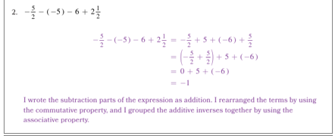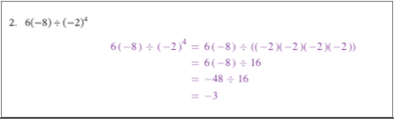
Rough lesson objectives | Use the order of operations and properties to evaluate numerical expressions containing rational numbers and exponents.
Terminology
Mathematical Models
Strategies | Order of operations
Specifications
Leaves to Include
Considerations | Word problems & estimates;  explain why an answer is reasonable using order  Justify steps by naming properties.  Order of operations is convention. Its only purpose is so we have to write down fewer grouping symbols. Avoid “gotcha” social media problems, unless to discuss when to use grouping symbols and when not to. What’s most important for kids to get is that our mathematical notation must be clear and unambiguous – grouping symbols help us do that, order of operations help us do that too.  (I don’t understand why this is here and not in exponent stem. -danielle s)
Required Skills/Cases | - Evaluate exponential expressions  - Same progression of cases as included in the Expressions (General) stem but using rational numbers  - Justify steps with named properties
Misconceptions | (-p)^2 = -p^2
Existing Product Reference, if any | EM2 Grade 7 Module 2 Lesson 24 Launch, Learn 1  EM2 Grade 7 Module 2 Lesson 24 Learn 2
Grade (or Leaf) | 7
Notes related to Standards, Grade, or Leaf | 7.NS.A.2.c  7.NS.A.3  7.EE.B.3  FL.7.NSO.1.2  TX.7.3B  AR.7.NCC.9  Focus only on using OOO with integers, 1 or 2 steps, real-world context: VA.6.CE.2.d  Focus on real-world problems:  FL.7.NSO.2.3  IN.8.NS.4  SC.6.PAFR.3.5
Notes for Intervention, Extension, or Optional Activities
Additional Notes | Would we want to establish informally that (negative rational number)^odd positive whole number is a negative rational number, where (negative rational number)^even positive whole number is a rational number?  Address difference between (-p)^2 and –(p^2).  2-3 days  Day 1- evaluate rational numbers raised to power; establish sign rules?  Day 2- evaluate expressions using OOO  Day 3- evaluate more complex expressions, word problems

